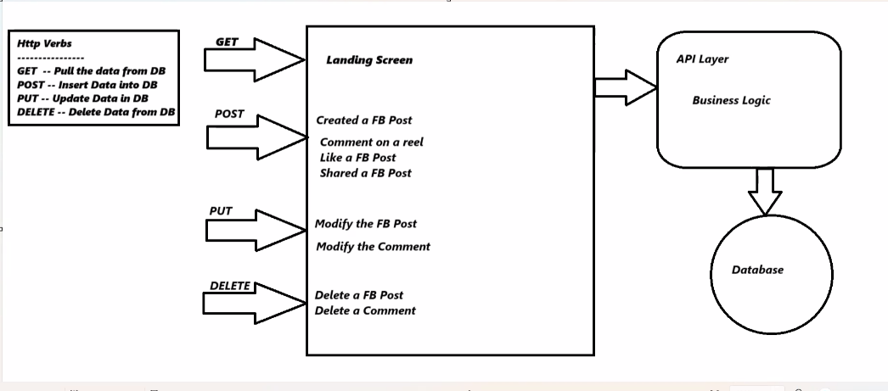

* **GET**: Retrieves data from the server/database (safe, idempotent)
* **POST**: Creates new data on the server (not safe, not idempotent)
* **PUT**: Updates existing data (not safe, idempotent)
* **DELETE**: Removes data (not safe, idempotent)

Landing Screen

* **GET** request to retrieve posts and content

Facebook Post Interactions

1. **Create a FB Post** → POST request
2. **Like a FB Post** → PUT request (updating like count)
3. **Share a FB Post** → POST request (creating new share instance)
4. **Modify the FB Post** → PUT request
5. **Delete a FB Post** → DELETE request

Comment Interactions

1. **Comment on a reel** → POST request
2. **Modify the Comment** → PUT request
3. **Delete a Comment** → DELETE request

System Architecture Layers

1. **API Layer**: Handles HTTP requests/responses
2. **Business Logic**: Processes application rules/operations
3. **Database**: Persistent data storage

Key Points

* GET should never modify data (only retrieve)
* POST creates new resources (results in new URLs)
* PUT replaces entire resources at known URLs
* DELETE removes resources at known URLs